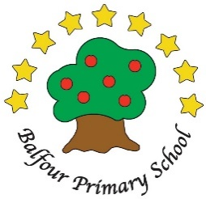
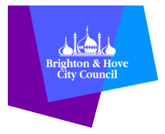
Relationships & Sex Education at Balfour School
Information for parents and carers

Why we teach Relationships & Sex Education at Balfour School:
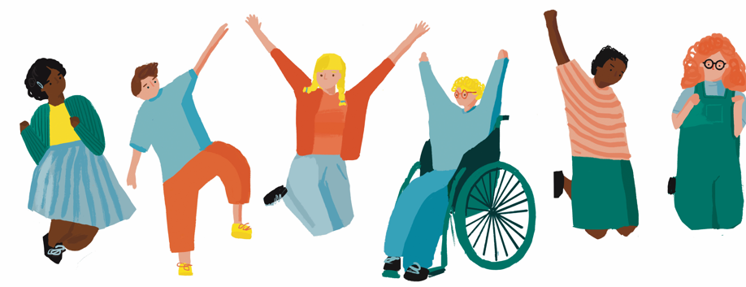
At our school, we use Brighton & Hove PSHE team resources to deliver an age appropriate and spiral Relationships and Sex education (RSE) curriculum with the aim of teaching the knowledge and skills to help our pupils to have happier, healthier, and safer lives, now and in the future.
We recognise how important families are in supporting children to understand and manage their changing bodies and their relationships with others as they grow from children to young adults.
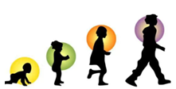
We aim to work in partnership with families to provide all pupils with clear factual information about how bodies work, how to manage their feelings and boost their self-esteem. RSE lessons provide a safe space to discuss and explore ideas, and the opportunity to practise the skills needed to navigate their friendships and to keep themselves safe.

At primary school, RSE is focused on friendships skills & healthy relationships, understanding puberty, families and people who care for us and how to keep healthy and safe. In Y6 topics on grown up relationships, marriage and human reproduction are also covered.
Our RSE curriculum meets the requirements of the Department for Education Relationships, Sex and Health Education statutory Guidance and the Equalities Duties on Schools.
Since 2021, Relationships Education is statutory for all pupils, although parents & carers have the choice of withdrawing their child from the sex education element of these RSE units of learning. Please note that this only covers a small number of the lessons. If you wish to discuss withdrawing your child we will, in the first instance, invite you in for a meeting to discuss your concerns.
Please refer to our PSHE policy for more details:
https://www.balfourprimary.co.uk/attachments/download.asp?file=568&type=pdf
Government guidance:
https://www.gov.uk/government/publications/relationships-sex-and-health-education-guides-for-schools

Research suggests that RSE does not encourage sexual behaviour instead it is effective in preventing harmful or risky behaviours (see reports from UNESCO and Sex Education Forum 2022).

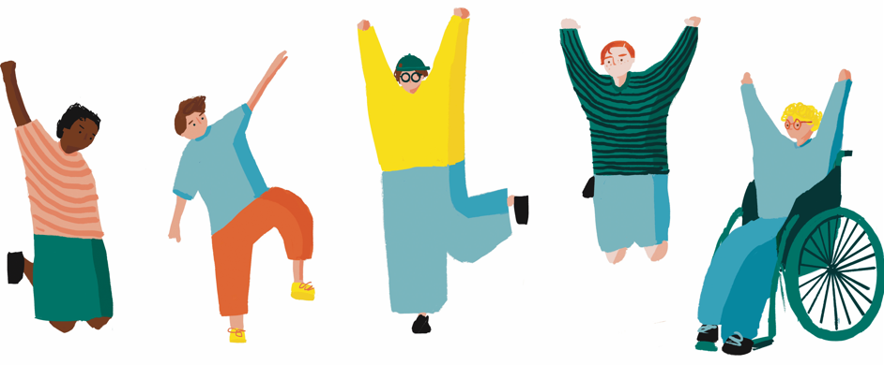

Safe Learning for All
All RSE lessons are taught by the class teacher, who creates a safe environment for learning with the use of ground rules, boundaries for asking questions, a variety of paired, group and whole class activities, and carefully chosen age-appropriate picture books and videos.
Care is given to provide appropriate support for pupils with additional needs. If you feel that your child may find any particular content challenging, we will work with you to order to ensure the learning environment and context is right for their stage of development and understanding.
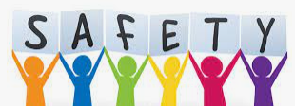

What we cover in RSE (including personal safety, sometimes called protective behaviours):
In Key Stage 1 (YR-Y2), we learn about:
- Naming body parts including scientific names for personal, private parts and the differences between male and female bodies
- Body positivity and celebrating our amazing bodies
- Keeping ourselves and others safe and how to get help
- How babies grow into children and looking after our bodies
- People who care for us and different types of family
- Gender Equality and challenging stereotypes about girls and boys
- Friendships skills and how to manage friendship ups and downs
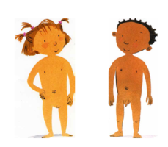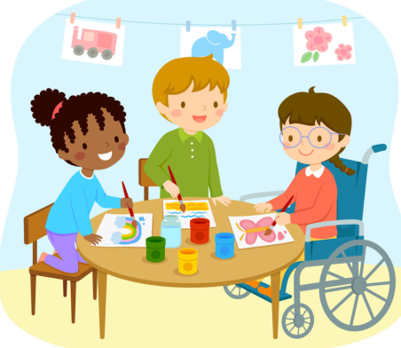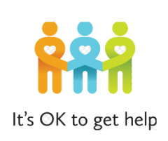

In Lower Key stage 2 (Y3-Y4) we learn about:
- How families grow and change over time (including marriage, separation, blended families and new siblings)
- What makes a healthy friendship and what to do when friendships go wrong
- Staying safe and managing risk and a focus on coping with worries
- Body positivity and self-confidence and strategies for boosting mood
- Light touch introduction to changes in puberty ( Y4)

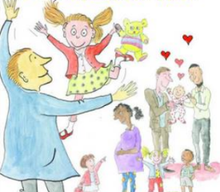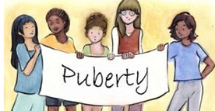
In Upper Key Stage 2 (Y5- Y6) we learn about:
- Emotional and physical changes in puberty
- Health & hygiene in puberty
- Staying safe online and age-appropriate sources of information
- Gender Equality and challenging stereotypes about girls and boys
- Body image and social media- critical thinking skills
- Grown up relationships, love, marriage and human reproduction (Y6)
- LGBT+ equality and understanding definitions and LGBT+ history and law (Y6)
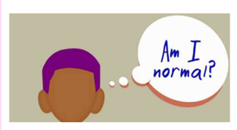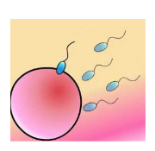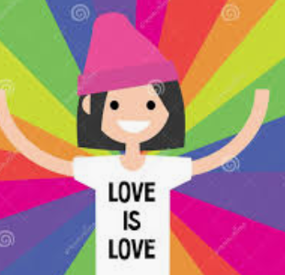
What our pupils say about RSE:
“It is important to learn about my body and how it changes so I feel prepared for things.”
“Learning about friendships changing and ending helps me to know how to make new friends and deal with problems.”

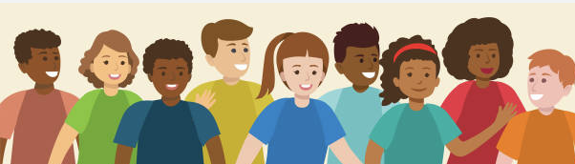

By the end of primary school, the aim is that all B&H pupils have understood these core messages to ensure they are prepared for their next stage of life at secondary school.

Core Messages for Y6 Pupils about Puberty and Relationships
1. In Your Own Time
At this age, some of you might start feeling attracted to or fancy people but some of you might not.
There is no set time for these feeling to start, so don’t worry if you don’t have these feelings.
2. Be Yourself
How you feel about yourself, and your gender identity and your relationships may change at this time or in the future.
You have a right to be who you want to be and not to be restricted by gender stereotypes.
3. Accept your changing body
Bodies develop at different speeds and into all different shapes and sizes, not just the ones you see in the media.
You have the right to ask questions and get support with these changes.
4. Enjoy it
Friendships should be fun!
If friends don’t make you feel good about being yourself, then are they good friends?
5. Stay Safe
You are the boss of your body; you have the right to say if you don’t like how you are being touched.
Pay attention to your early warning signs and talk to a trusted person if you feel at all uncomfortable.
6. Know Your Feelings
Puberty can be a very confusing time where you might find your mood changing often and you might have more extreme feelings about yourself and others.
Try and name your feelings and know that all feelings are ok, it is what you decide to do about them that matters.
7. Stay in Control
Think about what you share with others and telling or keeping secrets.
Notice your early warning signs and act on them!
8. Keep Talking
Keep talking to your friends and family and ask questions when you need to.
There’s nothing so awful (or too small) to talk to someone about.
9. Stay Connected
Remember there are people around you (parents, carers, trusted adults, teachers, mentors, ChildLine) you can get help and advice from if you’re faced with tricky decisions or situations or just need someone to talk to.

Top tips for talking to your child about bodies, growing up, relationships and sex
- Ask your child what they already know or understand
- Talk together when you’re involved in doing something else
- Use everyday situations to start conversations – such as television programmes, online articles etc
- Show your child that you are taking their questions seriously and listen carefully
- If you don’t know the answer to a question, say so, but find out and give them the facts later
- Have books and leaflets for your child to read or for you to look at together
- Remember that you have a right to privacy too – you don’t have to answer personal questions directly
- Your children might not take in everything you say, but you could provide them with a handful of clear and consistent messages – for example, ‘I will always try to answer your questions.’

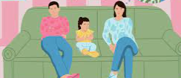

Suggested resources to support you in having these conversations

NSPCC advice for talking about difficult topics with your child https://www.nspcc.org.uk/keeping-children-safe/support-for-parents/talking-about-difficult-topics/
How to talk about sex from Big Talk education https://www.bigtalkeducation.co.uk/parents/how-to-talk-about-sex/
Amaze website - advice for parents and carers regarding RSE from America https://amaze.org/parents/
Puberty – Childline https://www.childline.org.uk/info-advice/you-your-body/puberty/

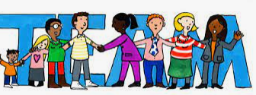
Working together:
The best learning occurs with partnership with pupil, parents and carers and the school. We hope that by sharing our RSE curriculum with families (full details on the website) you will be able to build on the conversations and learning at home to ensure your child has the knowledge and skills needed to be safe, have positive relationships and be confident to be themselves as they grow and change.
You can read our PSHE policy and see the whole curriculum overview on our website.
There will be opportunities to look in more detail at our RSE lesson resources, and to ask us questions at our Parent/carer meetings held annually.
Please contact us if you want to find out more or discuss any aspect of the statutory RSE at our school.
Dawn Loader, Deputy Head & Curriculum Lead PSHE
Jill Winch, Teacher & PSHE Lead


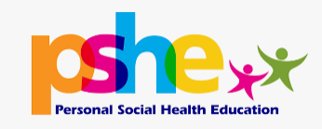
Happier, healthier and safer lives now, and in the future.

This booklet was produced by the B&H PSHE Team Primary PSHE lead teachers April 2023.
Amended by Balfour January 2024

Responsible Respectful Reflective Resilient

