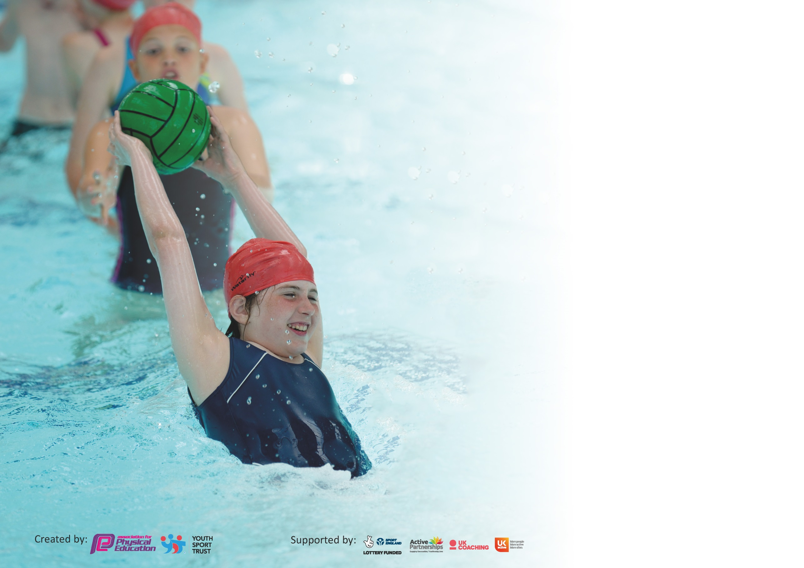

It is important that your grant is used effectively and based on school need. The Education Inspection Framework (Ofsted 2019 p64) makes clear there will be a focus on ‘whether leaders and those responsible for governors all understand their respective roles and perform these in a way that enhances the effectiveness of the school’.

Under the Quality of Education criteria (p41) inspectors consider the extent to which schools can articulate their curriculum (INTENT), construct their curriculum (IMPLEMENTATION) and demonstrate the outcomes which result (IMPACT).

To assist schools with common transferable language this template has been developed to utilise the same three headings which should make your plans easily transferable between working documents.

Schools must use the funding to make additional and sustainable improvements to the quality of Physical Education, School Sport and Physical Activity (PESSPA) they offer. This means that you should
use the Primary PE and Sport Premium to:

- Develop or add to the PESSPA activities that your school already offer
- Build capacity and capability within the school to ensure that improvements made now will benefit pupils joining the school in future years

Please visit gov.uk for the revised DfE guidance including the 5 key indicators across which schools should demonstrate an improvement. This document will help you to review your provision and to report your spend. DfE encourages schools to use this template as an effective way of meeting the reporting requirements of the Primary PE and Sport Premium.

We recommend you start by reflecting on the impact of current provision and reviewing the previous spend.

Schools are required to publish details of how they spend this funding as well as on the impact it has on pupils’ PE and sport participation and attainment by the end of the summer term or by 31st July 2020 at the latest.

We recommend regularly updating the table and publishing it on your website throughout the year. This evidences your ongoing self-evaluation of how you are using the funding to secure maximum, sustainable impact. Final copy must be posted on your website by the end of the academic year and no later than the 31st July 2020. To see an example of how to complete the table please click HERE.

Support for review and reflection - considering the 5 key indicators from DfE, what development needs are a priority for your setting and your pupils now and why? Use the space below to reflect on previous spend and key achievements and areas for development.

Key achievements to date until July 2019: | Areas for further improvement and baseline evidence of need:
Increase in the amount of teams’ participating against other schools.  Teachers qualified to deliver high quality swimming sessions.  New SL in KS1 trained and upskilled.  Platinum School Games Mark Award | Continued CPD opportunities for all staff.  Continued development of active lunchtimes across both Key Stages.  Development of teacher confidence and high quality delivery.  Continue to embed and exceed the active 30 minutes during the school day.  Development of lunchtimes to ensure all children are having the opportunity to be more active through more imaginative play situations.

Meeting national curriculum requirements for swimming and water safety.
What percentage of your current Year 6 cohort swim competently, confidently and proficiently over a distance of at least 25 metres?  N.B. Even though your pupils may swim in another year please report on their attainment on leaving  primary school at the end of the summer term 2020. | 98.6%
What percentage of your current Year 6 cohort use a range of strokes effectively [for example, front crawl, backstroke and breaststroke]? | 98.6%
What percentage of your current Year 6 cohort perform safe self-rescue in different water-based situations? | 98.6%
Schools can choose to use the Primary PE and Sport Premium to provide additional provision for swimming but this must be for activity over and above the national curriculum requirements. Have you used it in this way? | Yes/No

Action Plan and Budget Tracking
Capture your intended annual spend against the 5 key indicators. Clarify the success criteria and evidence of impact that you intend to measure to evaluate for pupils today and for the future.

Academic Year: 2019/20 | Total fund allocated: £23,400 | Date Updated: January 2020
Key indicator 1: The engagement of all pupils in regular physical activity – Chief Medical Officer guidelines recommend that primary school pupils undertake at least 30 minutes of physical activity a day in school |  |  |  | Percentage of total allocation:
 |  |  |  | 49%
Intent | Implementation |  | Impact
Your school focus should be clear what you want the pupils to know and be able to do and about  what they need to learn and to  consolidate through practice: | Make sure your actions to achieve are linked to your intentions: | Funding allocated: | Evidence of impact: what do pupils now know and what can they now do? What has changed?: | Sustainability and suggested next steps:
The focus – continue to ensure all pupils are engaged in physical activity. The target will be to embed and exceed the 30 mins of physical activity in the school day.  Introduce a Change of Life Club at lunchtime to get the children involved in activities.  Introduce the Active School plans for 30 active minutes per day through active travel, playgrounds and classrooms.  Purchase of spare PE kit  Continued development of KS1  Physical environment.  Development of a more active lunchtimes across both Key Stages | Identify a staff member to  undertake activities (possibly a  TA or MDSA) per Key Stage.  SL to arrange for staff members to go on the training.  Provide resources for the clubs to be run successfully.  SL to attend YST training.  SL to disseminate the training to SLT and then the rest of the staff.  Carry out a self-review  SL to set up the active school planner.  Purchase spare PE kit that is available for all year groups. This enables children to take part in PE if they forget kit or if issues at home mean children do not own appropriate kit. This therefore ensures PE is available for all, increasing participation levels and equality.  SLT to continue to develop environment to help encourage more physical activity.  Discussion with children  Purchase of equipment.  SLT and a key member of staff are going to be working with OPAL to complete an audit of current lunchtime activities and then help implement more free play/ active times. | £800  £250  £400  £5000  £5000 | Carried forward 20/21  Carried forward 20/21  PE Kit purchased and sent out to all year groups. Some kit has since gone missing so more funding may need to be invested in 20/21.  Contributed to by FAB fundraising  Carried forward 20/21
Key indicator 2: The profile of PESSPA being raised across the school as a tool for whole school improvement |  |  |  | Percentage of total allocation:
 |  |  |  | 5%
Intent | Implementation |  | Impact
Your school focus should be clear what you want the pupils to know and be able to do and about  what they need to learn and to  consolidate through practice: | Make sure your actions to achieve are linked to your intentions: | Funding allocated: | Evidence of impact: what do pupils now know and what can they now do? What has changed?: | Sustainability and suggested next steps:
The focus – continue to develop the understanding of staff to use PESSPA as a tool for whole school improvement. Consolidate 2 hours of PE in the curriculum to ensure the children are developing the skills needed to a healthy life style.  Further embed 2 hours per week of physical and emotion education.  Purchase of teachers PE jumpers and t-shirts. | SL to carry out a learning walk and make amendments to allow for more emotional education to be built into the curriculum not just in PE.  Purchase resources if required.  Purchase of staff PE kit allows the profile of PE to be raised across the school.  Children see the teachers showing how important PE is. | £500  £500 | Carried forward 20/21  Carried forward 20/21

Key indicator 3: Increased confidence, knowledge and skills of all staff in teaching PE and sport |  |  |  | Percentage of total allocation:
 |  |  |  | 15%
Intent | Implementation |  | Impact
Your school focus should be clear | Make sure your actions to | Funding | Evidence of impact: what do | Sustainability and suggested
what you want the pupils to know | achieve are linked to your | allocated: | pupils now know and what | next steps:
and be able to do and about | intentions: |  | can they now do? What has
what they need to learn and to |  |  | changed?:
consolidate through practice:
Focus – With the implementation of the new PE curriculum we have introduced last academic year, the focus will be on continuing to develop the knowledge and skills of staff. This will lead to pupils receiving a higher quality PE lesson.  Development of staff confidence in delivery of PE across both Key Stages to ensure that they are providing clear and explicit teaching points to all children.  Ensured the 2 staff responsible for swimming attend appropriate course and gain qualifications in order to teach swimming effectively.  Joined afPE (School Membership) to ensure access to specialist and expert support, thus keeping the school fully up to date.  Continued membership of Youth Sport Trust to allow KS1 staff access to the Physical Literacy learning resources and allow access to the PE quality mark.  Subject Leader undertook YST training courses in order to up-skill her own knowledge and understanding so she can confidently disseminate to all staff, thus increasing their knowledge and confidence.  Continued programme of CPD opportunities for all staff continued based on local courses offered by NGBs. | Complete Learning walk to allow action plan to be completed to show strengths and areas of development in readiness for OFSTED.  Liaise with SLT to ensure staff meeting time was allocated in order to disseminate to staff.  Provided cover so SL could team teach/observe all members of staff at least once.  Access appropriate course advertised through the School Games Organiser.  Ensure that cover is provided for other teachers to work alongside these two staff in order to gain knowledge and confidence.  Continued development of staff’s understanding of certain areas of PE.  Accessed membership information on afPE website.  CPD opportunities linked to PE planning.  3 teachers have attended Top Dance Course.  2 Teachers have attended FA Primary Teachers course linked to feedback from PE subject evaluations | £1000  £500  Youth Sport Trust membership £270.  Supply Costs  £1000 | Carried forward 20/21  PE PDM carried out end of Summer 2 to gauge staff confidence. Feedback to be collated in autumn term and CPD needs assessed.  Completed – both teachers fully trained.  Completed  Completed | Membership will be renewed each year from the school budget if PE and Sport funding is discontinued.
Key indicator 4: Broader experience of a range of sports and activities offered to all pupils |  |  |  | Percentage of total allocation:
 |  |  |  | 14%
Intent | Implementation |  | Impact
Your school focus should be clear | Make sure your actions to | Funding | Evidence of impact: what do | Sustainability and suggested
what you want the pupils to know | achieve are linked to your | allocated: | pupils now know and what | next steps:
and be able to do and about | intentions: |  | can they now do? What has
what they need to learn and to |  |  | changed?:
consolidate through practice:
Focus – Provide the children with a wider range of sports and activities. Target certain groups of children to experience other activities to help with their mental wellbeing and physical wellbeing. Consolidation of the curriculum. Children will take part in an enrichment week to experience even broader range of sports and activities. Provide funding to allow specific groups of children to experience a wider range of sports and activities.  Purchase of new resources to help support a broad experience to all pupils.  Curriculum Review to ensure KS1 pupils receive a broader experience.  Support and payment for targeted children to attend extra-curricular sporting and physical activities. | SL to arrange to purchase resources for all areas  KS2 SL to work with KS1 SL to carry out a subject review.  Modify/ amend KS1 PE curriculum Staff training/ monitoring to be carried out to ensure curriculum is implemented.  Discussion with SLT and LM to target specific children who would benefit from experiencing a wider range of activities to help with physical and mental wellbeing.  Eg attending after school football clubs, yoga during school time. | £1500  £1000 to cover supply costs and resources.  £1000 | Resources purchased  Completed  Completed

Key indicator 5: Increased participation in competitive sport |  |  |  |  | Percentage of total allocation:
 |  |  |  |  | 18%
Intent | Implementation |  |  | Impact
Your school focus should be clear | Make sure your actions to |  | Funding | Evidence of impact: what do | Sustainability and suggested
what you want the pupils to know | achieve are linked to your |  | allocated: | pupils now know and what | next steps:
and be able to do and about | intentions: |  |  | can they now do? What has
what they need to learn and to |  |  |  | changed?:
consolidate through practice:
Focus – continue to take as many teams as possible to a range of competitive sports events subject to the School Games Organiser requirements and restrictions. Be able to provide transport to these fixtures to ensure all children have the opportunity to attend not just children whose parents can provide transport.  Invest in new t-shirts that the children can wear to these sporting events and feel pride in representing the school.  Allow all children who are selected to represent the school to travel to the sporting event.  Purchase new PE t shirts for children to wear when they take part in competitive events for the school. |  | Provide transport to sporting events that take place during the school day.  Cover the costs of supply teachers to allow the SL or coach to attend the fixture.  Allow the children to show pride in their school they are representing | £2000  £2000  £300 | Carried forward 20/21  Carried forward 20/21  Completed

Signed off by
Head Teacher: | Simon Davies
Date: | 21.7.20
Subject Leader: | Laura Porter and Lily Freeman
Date: | 20.7.20
Governor: | Governing body
Date: | 01.08.20

